In order to notify Budget that a project is ready for funding approval, Program Officers must log in to PAMS and confirm their project’s funding mechanism. Program Officers will receive an email from **noreply@ctprograms.com** that reads, *“This is to notify you that a CN has been APPROVED for Proposal XYZ. Please confirm the funding mechanism type for each of these activities, which are now in your workload summary.”*

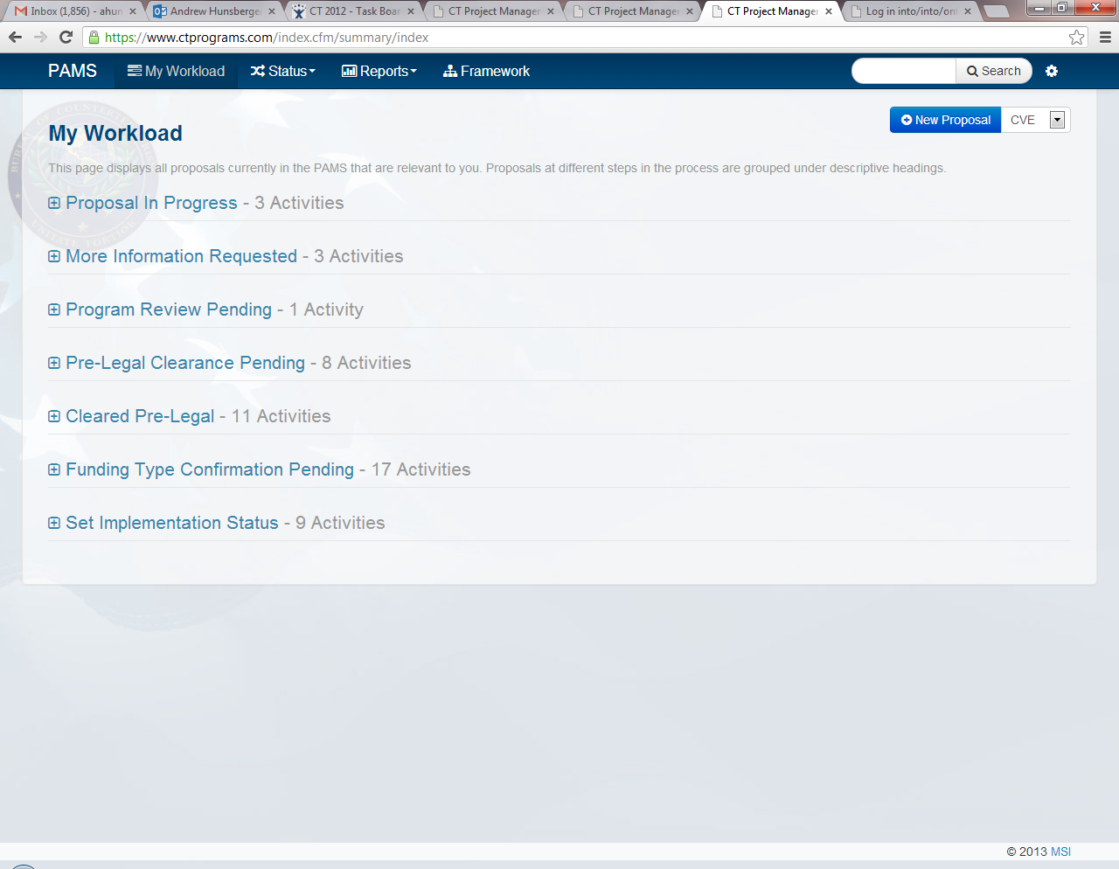Program Officers will log in to PAMS, access their Workload Summary, and select   
**“Funding Type Confirmation Pending”.**

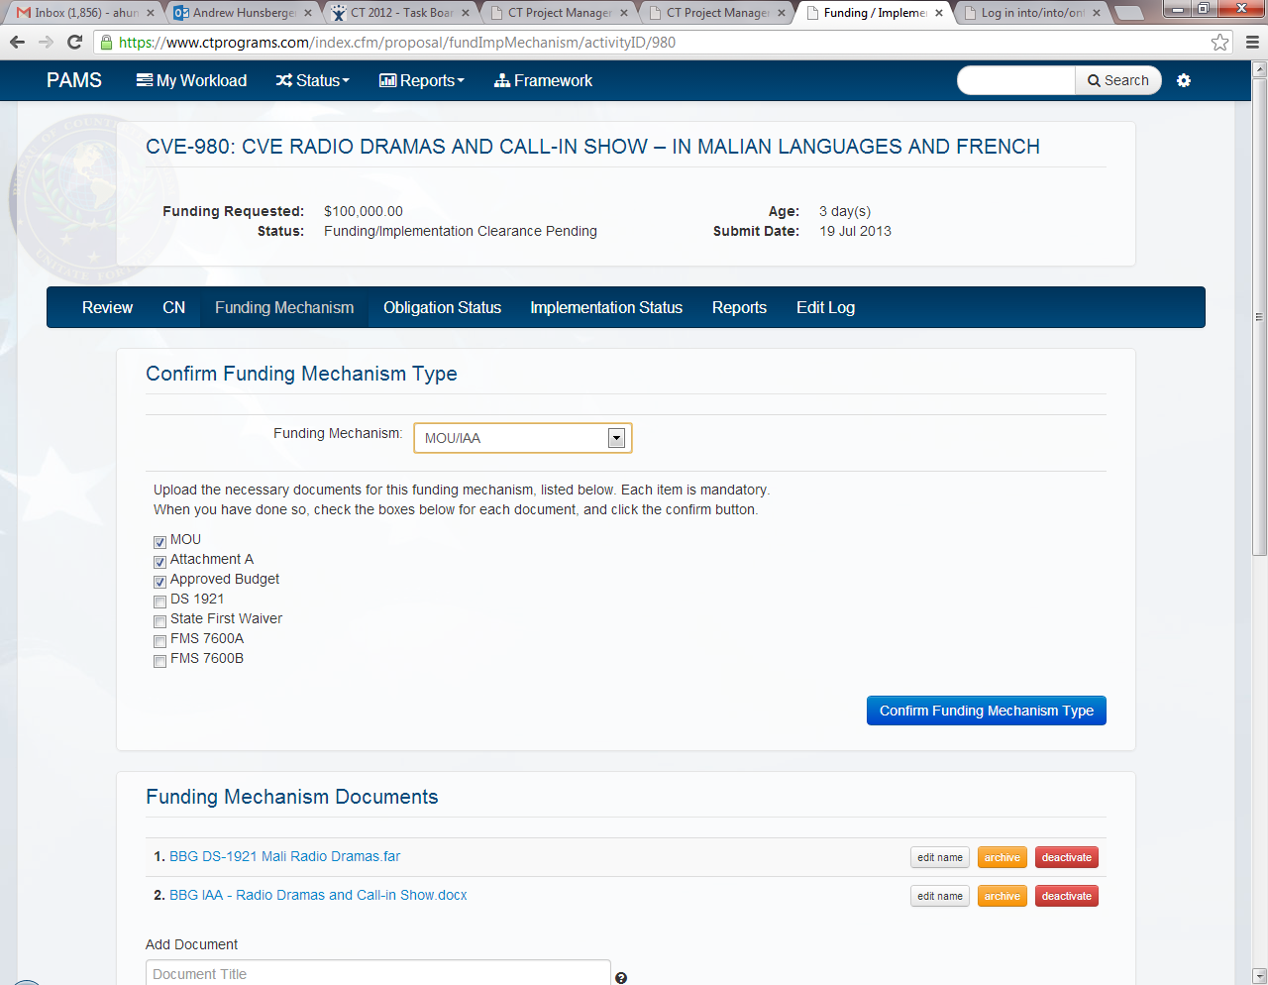Program Officers will open the project in question, select the correct funding mechanism, and complete the necessary steps listed on the checklist.

Program Officers will confirm the necessary steps have been completed by checking the corresponding boxes. Once all the boxes are checked, Program Officers will click the **“Confirm Funding Mechanism Type”** button to complete the process.  
*Budget will automatically be notified via email that the project in question is ready for funding clearance.*